# Task1

CSE221: Algorithms

Lab 04: DFS

## Write a program to implement DFS for any given graph.

**Depth-first search (DFS)**

Starts from the source vertex (an arbitrary node) and explores as far as possible along each branch before backtracking.

Search deeper into the graph, similar to pre-order traversal in tree.

**Sample Input:** a graph (with file input):

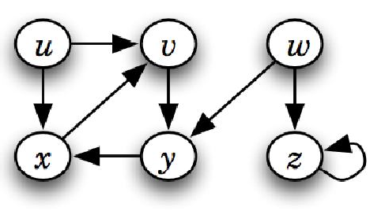

## Sample Output: x, y, v, u, z, w

